The UCATS tracks, coordinates, and directs airborne Unmanned Air Vehicles (UAVs) being used for mobile Target of Interest (TOI) tracking operations in an urban environment. The UCATS will reduce the manpower requirements encountered in the management of UAVs and the time required to generate an optimum plan to have airborne UAVs intercept a TOI. Currently, the coordination and control of UAVs is a resource-intensive task in terms of manpower. The task of coordinating and controlling a single UAV requires several operators. The UCATS reduces the manpower resources by determining which in-flight UAVs are best capable to track TOIs, recommending a UAV intercept course, monitoring the position of the UAVs, and providing re-tasking if the operator needs to track a new TOI. Additionally, the time needed to generate intercept tasking is important when considering the TOIs are mobile, and the shorter the time to generate intercept tasking the better the prediction of where the TOIs may have gone, which increases the likelihood the UAVs will find the TOI to track. This collaborative control will increase efficiency, save money and resources, and aide in security and homeland defense.

UCATS consists of a ground based Command & Control (C2) center. The external systems that must interact with UCATS includes a manned by an operator and up to five airborne UAVs. UCATS will provide a decision support component to enable effective communication from the operator to the UAVs conducting the mission. The UCATS will be responsible for initiating and updating assignments to the UAVs in-flight based on the urban environment and TOI information given by Intel. Figure 1 provides a notional view of the UCATS Concept of Operation (CONOPS).

Operationally, the UCATS recommends an intercept plan to the operator, communicate with UAVs, provide surveillance video from the UAVs to the operator, and accept operator’s requests and provide feedback. The intercept plan includes predicting the TOI location at UAV intercept, determining if the intercept is feasible, recommending a UAV intercept course, and recommends a UAV-to-TOI assignment. Initially, the UCATS operator will receive tasking to have one to five airborne UAVs track one to five TOIs. The operator will input intercept tasking requirements and set-up preferences, which include the TOI location and description, TOI priorities, and current local area maps, which include no-fly zones. Additionally, if the information is available, the operator can input the last known TOI heading and speed. The UCATS will then use those tasking requirements to generate an intercept plan. The operator will then use the UCATS recommendations to designate which UAV(s) should track which TOI(s). The UCATS will then communicate with the UAVs and direct the UAVs to follow the UCATS calculated route to the TOI. The UCATS will monitor the position of the UAVs. As the operators, receives new TOIs and tasking, they will then use the UCATS to re-evaluate the UAV tasking and then redirect the UAVs as needed.

The use of UCATS in conjunction with UAVs that can autonomously track TOIs has several potential uses. A system such as this could be used by the Department of Defense in the execution of the Global War On Terror (GWOT). Other agencies within the United States Government could have uses for this system such as: Border Patrol, Drug Enforcement Administration, Federal Bureau of Investigation, Homeland Security, and the Central Intelligence Agency.
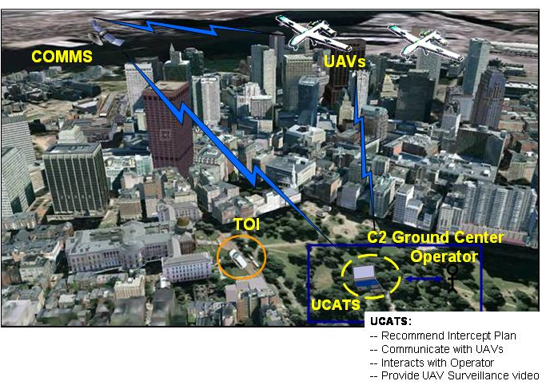

Figure 1: UCATS CONOPs

